STUDENT ATTENDANCE SYSTEM SPECIFICATION DOCUMENT

Student attendance system | Version: 1.0
System specification | Date: 01/11/2026

DOCUMENT CHANGE RECORD
Date | Version | Description | Author
01/11/2026 | 1.0 | Document created

- FUNCTIONAL REQUIREMENTS
  - System description
The Student Attendance System is a platform designed to assist educational institutions in managing attendance-related data. It enables instructors to conduct attendance checks using various methods, allows students to participate and track their own attendance records and provides features for handling disputes, generating statistics, sending notifications, maintaining logs and performing data backups.
  - Main function
Account and Login management
- Admin creates, updates, locks, and unlocks Student and Lecturer accounts. The system does not support self-registration.
- Admin, Lecturer and Student can login, log out, and change their password. Users must change their password on their first login.
- Users can recover their passwords using an OTP sent to their registered email address.
Data and Schedule management
- Admin manages student and lecturer information, deparments, courses, course section and course enrollment lists.
- Admin creates, updates and cancels class schedule and can create make-up class schedule. Cancelled schedules remain recorded in the system.
Attendance session management
- Lecturer opens, ends or re-opens an attendance session based on an established class schedule.
- Each attendance session uses one of four methods selected by the Lecturer: QR code, password, QR code combined with password or manual attendance.
- When attendance is re-opened, the system creates a new attendance session and preserves the previous session’s data.
Recording attendance
- For QR code attendance, Student logs in and scans a dynamic QR code. The QR code changes according to the configured interval; the previous code becomes invalid when a new code becomes active or when the attendance session ends.
- For password attendance, Lecturer creates a password for the session and Student enters it to confirm attendance.
- For the combined method, Student scans the QR code first and then enters the password. Both steps must be valid before attendance is recorded.
- For manual attendance, Lecturer records attendance using a student list or by calling student’s names or student IDs.
- After five incorrect password attempts, the Student is blocked from entering the password for the current session. The user account is not locked.
- Each Student can have only one attendance result per session. Repeated actions must not create duplicate records.
Attendance Results and Complaints
- Lecturer views and edits attendance results. The available statuses are Present, Absent, Late, and Excused.
- The system records the account that made the change, the time of the change, and the status before and after the change.
- Student submits a complaint about an attendance result. The Lecturer responsible for the course section receives, responds to, and decides whether to accept or reject the complaint.
- Complaint statuses are Pending, In Progress, Accepted, and Rejected.
Look-up, Statistics and Reports
- Student views their class schedule, personal attendance history, and personal attendance statistics.
- Lecturer views attendance results and statistics for assigned course sections.
- Lecturer views attendance results and statistics for assigned course sections.
- Lecturer can export attendance reports by session, course section, or student.
Notifications, Activity logs and Backup
- The system sends in-app and email notifications about class schedules, attendance sessions, attendance results, and complaint responses.
- The system records successful logins and important activities, including the user account, time, action, affected object, and result.
- The system records successful logins and important activities, including the user account, time, action, affected object, and result.
- NON-FUNCTIONAL REQUIREMENTS
2.1 Usability
The system shall provide a clear and easy-to-understand interface suitable for the Admin, Lecturer, and Student roles. Each user shall only be presented with functions permitted for their role.
The Student interface shall be convenient to use on mobile devices, especially for login, QR code scanning, attendance-password entry, viewing attendance history, and submitting complaints.
The Lecturer interface shall support the management of assigned course sections, attendance sessions, attendance results, and complaints.
The system shall display clear messages after a successful user action and when an action cannot be completed.
The system shall validate required fields before a form is submitted. If information is missing or invalid, the system shall identify the content that needs to be corrected.
The attendance screen shall display the attendance method selected by the Lecturer for the current session. Students shall only be able to submit attendance using the selected method.
Attendance statuses shall be displayed consistently as Present, Absent, Late, and Excused. Complaint statuses shall be displayed consistently as Pending, In Progress, Accepted, and Rejected.
2.2 Reliability
The system shall confirm successful attendance only after the server has validated and saved the attendance result.
When the network is unavailable or the server has not confirmed a request, the system shall not consider the attendance submission successful.
The system shall prevent duplicate attendance records. Each Student shall have only one attendance result for the same attendance session.
When a Lecturer re-opens attendance, the system shall create a new session and preserve the data of the previous session.
When a new QR code becomes active, the previous QR code shall become invalid. A QR code shall also become invalid when the attendance session ends.
For the QR Code + Password method, the system shall record attendance only when both the QR code and the password are valid.
After five incorrect attendance-password attempts, the Student shall be blocked from entering the password for the current session. The user account shall not be locked.
Each attendance-result change shall be recorded with the account that made the change, the time of the change, the previous status, and the new status.
Cancelled class schedules shall remain stored in the system with their cancelled status and shall not be deleted from the data.
2.3 Performance
Under a stable network connection, the system shall confirm a valid attendance request within 3 seconds after the Student submits it.
The system shall support at least 1,000 concurrent users under normal operating conditions. Login, information retrieval, and attendance operations shall remain stable during this period.
The 3-second attendance-confirmation period shall be measured from the time the Student submits the request until the server confirms that the result has been saved.
Displayed attendance results shall correspond to the course section and attendance session selected by the user.
Lecturer search results shall be limited to the course sections assigned to that Lecturer.
2.4 Supportability and Maintainability
The system shall record successful logins and important activities, including the user account, time, action, affected object, and result.
Activity logs shall be protected. Normal users shall not be allowed to modify or delete them.
The system shall support database backup and restoration by an Admin with the required permissions.
Backup information shall make it possible to identify the backup and the status of the backup or restoration operation.
When an operation fails, the system shall inform the user that the operation has not been completed.
2.5 Security
Admin, Lecturer, and Student shall log in before accessing functions that require authentication. The system shall not support self-registration.
The system shall enforce role-based access control. Admin may manage accounts and system data but shall not edit attendance results. Lecturer may manage only assigned course sections. Student may view only their own attendance information.
Users shall be required to change the initial password at their first login.
Account passwords shall be stored as secure password hashes and shall not be stored or displayed as plain text.
Password recovery shall use an OTP sent to the user's registered email address. The password shall only be changed after successful verification.
The system shall validate the current password and the new password before changing the password.
Attendance passwords shall be stored securely and shall not be stored as plain text.
The system shall invalidate an old QR code when a new code becomes active or when the attendance session ends.
A Lecturer shall not access or modify attendance sessions and results belonging to course sections not assigned to them.
A Student shall not view or modify another Student's attendance information.
Normal users shall not be allowed to modify or delete activity logs.
The system shall validate input data and reject invalid or unauthorized requests before saving data.
2.6 Compatibility and Design Constraints
The system shall operate on popular web browsers, including Google Chrome, Mozilla Firefox, Microsoft Edge, and Safari.
The system interface shall be compatible with desktop computers, laptops, tablets, and smartphones.
The system shall support devices running Windows, macOS, Android, and iOS.
The system shall be developed as a web-based application.
The server-side application shall use Python with the Flask framework.
The user interface shall use HTML, CSS, and Bootstrap.
The system shall use MySQL as its database management system.
Visual Studio Code shall be used as the programming environment.

- Data flow diagram (DFD)
            - DFD Level 0 – Context diagram

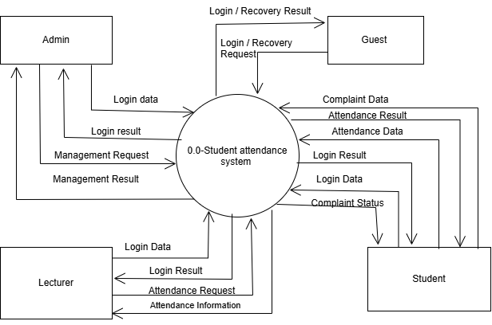
            - DFD Level 1 – System Decomposition
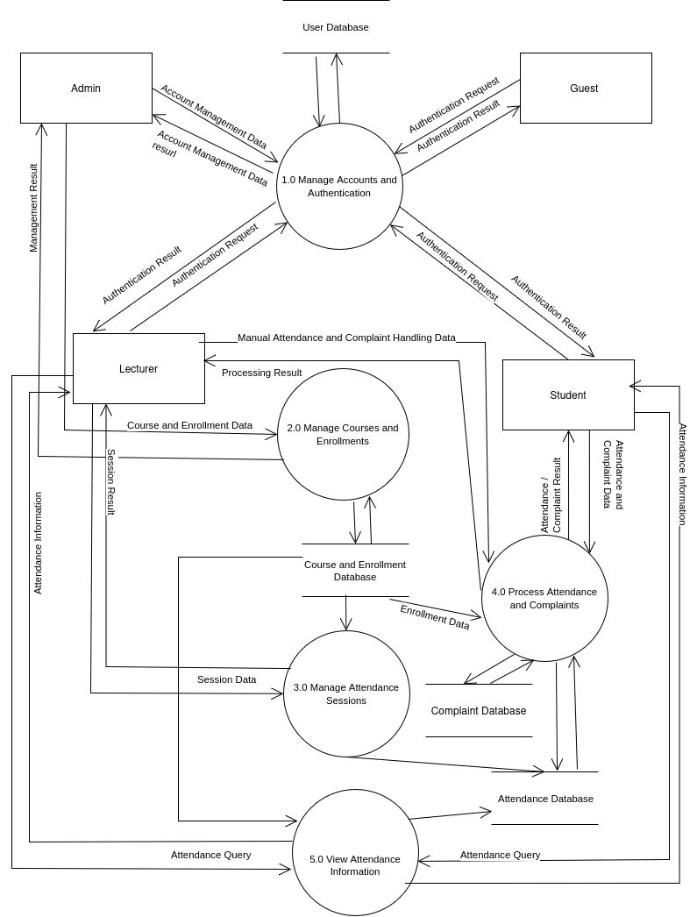

- Use-case Model
            - Overview diagram
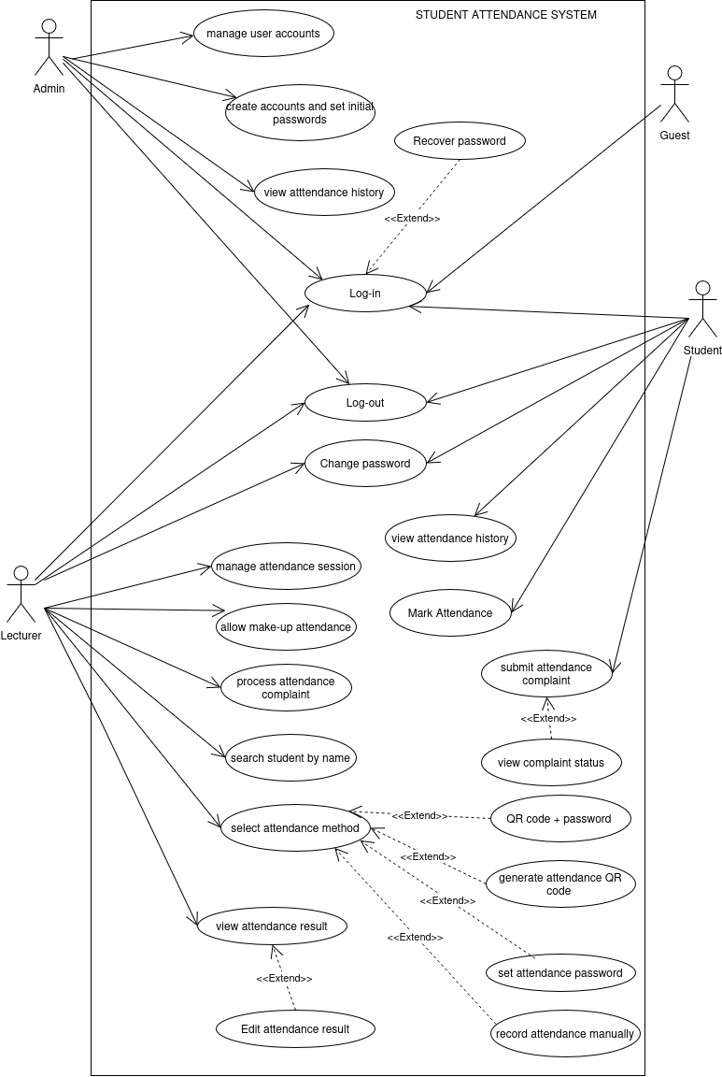

- List of Actor
No. | Actor | Description
1 | Admin | Manages user accounts and the administrative tasks identified by the group.
2 | Lecturer | Organizes attendance sessions for assigned course sections and monitors and manages attendance results.
3 | Student | Marks attendance and views their own attendance results.
4 | Guest | An unauthenticated user who can log-in or recover a password.

- List of Use-case

No. | Use-case | Description
1 | Mark attendance | Allows students to record their attendance.
2 | View attendance his | Allows students to view their own attendance history.
3 | Submit attendance complaint | Allows students to submit a complaint about an attendance result.
4 | View Complaint Status | Allows students to track the status of their complaints.
5 | Log-in | Allows users to log in to the system.
6 | Log-out | Allows authenticated users to log out of the system.
7 | Recover Password | Allows users to recover their account password.
8 | Change Password | Allows authenticated users to change their password.
9 | Manage Attendance Session | Allows lecturers to create, manage, stop, or reschedule attendance sessions.
10 | Select Attendance Method | Allows lecturers to select an attendance method for each session.
11 | Generate Attendance QR Code | Generate Attendance QR Code
12 | Set Attendance Password | Allows lecturers to set a password for an attendance session.
13 | Record Attendance Manually | Allows lecturers to record students’ attendance manually.
14 | View Attendance List/Results | Allows lecturers to view attendance lists and results
15 | Search Student by Name | Allows lecturers to search for a student by name.
16 | Edit Attendance Result | Allows lecturers to edit an attendance result.
17 | Allows lecturers to edit an attendance result. | Allows lecturers to review and process attendance complaints.
18 | Allow Make-up Attendance | Allows lecturers to permit make-up attendance.
19 | Manage User Accounts | Allows admins to create and manage user accounts and set initial passwords.
20 | View Student Attendance History | View Student Attendance History
            - Use-case log-in
  - Summary
This use case allows a student to record attendance for an attendance session opened by the lecturer. The student uses the method selected by the lecturer for that session: scanning a QR code, entering a password, or scanning a QR code and entering a password. The lecturer may also record attendance manually.
  - Flow of events
- Main flow:
- The use-case begins when the guest selects the Log in function.
- The system displays the login screen.
- The guest enters a username and password.
- The guest submits the login information.
- The system validates the credetials.
- If the credentials are valid, the system creates a login session and displays the interface appropriate to the guest’s role.
- Alternative flows:
- If the guest omits the username or password, the system indicates that all required information must be entered and asks the guest to try again.
- If the username or password is incorrect, the system reports that login failed and allows the guest to try again.
  - Special requirements:
Login credetials must be validated before access is granted. The password must not be displayed as plain text on the screen.
  - Pre- conditions:
The guest is not logged in to the system.
The guest has been provided with an account created by the Admin.
  - Post-conditions:
If login is successful, the system creates a login session and grants access to functions according to the guest’s role. If login fail, the guest remains unauthenticated.
  - Extension points: None.
- Use-case mark attendance
  - Summary
This use case allows a student to record attendance for an attendance session opened by the lecturer. The student uses the method selected by the lecturer for that session: scanning a QR code, entering a password, or scanning a QR code and entering a password. The lecturer may also record attendance manually.
  - Flow of events
- Main flow:
- The use case begins when the student accesses the attendance function for an open attendance session.
- The system displays the attendance session information and the method selected by the lecturer.
- The student follows the required method: scans the QR code, enters the password, or performs both actions if the session uses the combined method.
- The system validates the submitted attendance information.
- If the information is valid and the student has not already been recorded for this session, the system saves the attendance result.
- The system notifies the student of the attendance result.
- Alternative Flows:
- If the student scans an invalid or expired QR code, the system reports that attendance cannot be verified and asks the student to try again with valid information.
- If the student enters an incorrect attendance password, the system reports that the information is invalid and asks the student to enter it again.
- If the student has already been recorded for the current session, the system does not create another attendance record and informs the student that attendance has already been recorded.
- If the attendance session is no longer open, the system informs the student that attendance cannot be recorded for this session.
- For manual attendance, the lecturer selects the student and records the attendance directly in the system. The system saves the attendance result.
  - Special Requirements:
Each student can be recorded as attending only once per attendance session. The attendance QR code changes periodically to reduce code sharing. Attendance confirmation should take no more than 3 seconds under stable network conditions.
  - Pre-condition:
The student is logged in to the system. The relevant attendance session has been opened by the lecturer. The lecturer has selected the attendance method for the session.
  - Post-conditions:
If attendance is successful, the system saves the student's attendance result for the relevant session. If attendance is unsuccessful, the system does not create a new attendance record.
  - Extension Points: None.
- . Use-case View Attendance History
4.1. Summary
This use case allows a student to view their own attendance history, including attendance results recorded in the system.
4.2 Flow of Events
- Main flow:
- The use case begins when the student selects the View Attendance History function
- The system retrieves the attendance records belonging to the currently logged-in student account.
- The system displays the student's attendance history.
- The student reviews the displayed attendance information and results.
- Alternative Flows:
- If the student has no attendance data, the system displays a message indicating that no attendance history is available.
- If the data cannot be retrieved due to a system error, the system informs the student that the attendance history cannot be loaded and allows them to try again later.
  - Special Requirements
The system displays only the attendance history belonging to the currently logged-in student. A student is not permitted to view another account's attendance history.
  - Pre-conditions
The student is logged in to the system using an account created and provided by the Admin.
  - Post-condition
The system displays the student's attendance history. Attendance data is not modified by this use case.
  - Extension Points: None
- Use-case View Complaint Status
  - Summary
This use case allows a student to view the processing status of attendance complaints they have submitted
  - Flow of Events
- Main Flow:
- The use case begins when the student selects the View Complaint Status function.
- The system retrieves the complaints submitted by the currently logged-in student.
- The system retrieves the complaints submitted by the currently logged-in student.
- The system retrieves the complaints submitted by the currently logged-in student.
- Alternative Flows
- If the student has not submitted any complaints, the system displays a message indicating that no complaints are available.
- If complaint data cannot be loaded due to a system error, the system displays an error message and allows the student to try again later.
  - Special Requirements
The system displays only complaints belonging to the currently logged-in student. Complaint statuses must be clearly displayed using the defined statuses: Pending, In Progress, Accepted, and Rejected.
  - Pre-conditions
The student is logged in to the system using an account created and provided by the Admin.
  - Post-conditions
The system displays the processing statuses of complaints submitted by the student. Complaint data is not modified by this use case.
  - Extension Points: None
- Log Out
  - Summary
This use case allows an authenticated user (Student, Lecturer, or Admin) to log out of the system and end the current session.
  - Flow of Events
- Main Flow
- The guest selects the Log Out function.
- The system terminates the current login session.
- The system redirects the user to the login page.
- Alternative Flows : None
  - Special Requirements
After logging out, the user must no longer be able to access functions that require authentication through the terminated session.
  - Preconditions
The user is logged in to the system.
  - Postconditions
The user's login session has been terminated; the user is unauthenticated.
  - Extension Points: None
- Recover Password
  - Summary
This use case allows a user to recover access to their account when they cannot log in because they have forgotten their password.
  - Flow of Events
- Main Flow
- The user selects Recover Password on the login page.
- The system asks the user to provide the account information to be recovered.
- The user enters the account information and submits the request.
- The system receives the request and performs the password recovery process using the configured mechanism.
- Alternative Flows
- Invalid or unrecognized account information: The system notifies the user to check and re-enter the information.
- The request cannot be processed due to a system error: The system informs the user that the request could not be completed.
  - Special Requirements
The password recovery process must protect user account security. The specific verification method has not yet been defined in the current requirements.
  - Preconditions
The user is not logged in and has an account created by the Admin.
  - Postconditions
The password recovery request has been received by the system, or the user has been informed why the process cannot continue. The password is changed only after the recovery process is successfully completed.
  - Extension Points: None
- Change Password
  - Summary
This use case allows an authenticated user to change the password of their current account.
  - Flow of Events
- Main Flow
- The user selects the Change Password function.
- The system displays the change-password form.
- The user enters the current password and a new password that meets the system requirement.
- The user submits the password change request.
- The system validates the provided information.
- If the information is valid, the system updates the password and notifies the user that the change was successful
- Alternative Flow
- Incorrect current password: The system displays an error and asks the user to check it
- The new password does not meet the system requirements: The system notifies the user to enter another password.
- The new password and its confirmation do not match (if the form includes a confirmation field). The system notifies the user to re-enter them.
  - Special Requirements
Passwords must be stored securely. The system updates the password only after the current password and the new password have been validated successfully.
  - Preconditions
The user is logged in to the system.
  - Postconditions
The account password is updated to the new password if the request is valid.
  - Extension Points: None
- Manage Attendance Session
  - Summary
This use case allows a Lecturer to create, view, update, start, pause, or end an attendance session for a course section assigned to them.
  - Flow of Events
- Main flow
- The Lecturer logs in and accesses the Manage Attendance Session function.
- The system displays the course sections assigned to the Lecturer.
- The Lecturer selects a course section.
- The Lecturer chooses to create a new attendance session or selects an existing session to view or update.
- The Lecturer enters or updates session information and starts, pauses, or ends the session.
- The system validates the information and saves valid changes.
- The system validates the information and saves valid changes.
- Alternative Flows
- The Lecturer has no assigned course sections: The system does not display any course section for management.
- Invalid attendance session information: The system displays an error and asks the Lecturer to review and correct it.
- Changes cannot be saved due to a system error: The system informs the Lecturer that the operation was not completed.
  - Special Requirements
A Lecturer may manage attendance sessions only for assigned course sections. The attendance session status must be updated consistently when a session is started, paused, or ended.
  - Preconditions
The Lecturer is logged in and has at least one assigned course section.
  - Postconditions
  - Extension Points
While managing an attendance session, the Lecturer can configure a suitable attendance method for that session. Depending on the selected method, the system supports QR code generation, attendance password configuration or manual attendance recording.
- Select Attendance Method
  - Summary
This use case allows a Lecturer to select the attendance method for a specific attendance session.
  - Flow of Events
- Main Flow
- The Lecturer accesses the attendance session to be configured.
- The Lecturer selects the Select Attendance Method function.
- The system displays the supported attendance methods.
- The Lecturer selects one of the following methods: QR Code, Password, QR Code + Password, or Manual Roll-call.
- The Lecturer confirms the selection.
- The system saves the attendance method for the corresponding session and displays the result.
- Alternative Flows
- The Lecturer does not select a method: The system does not save a selection and keeps the current configuration.
- The method cannot be saved due to a system error: The system displays an error and does not change the session configuration
  - Special Requirements
Each attendance session uses the method selected by the Lecturer. The system must support all four agreed methods: QR Code, Password, QR Code + Password, and Manual Roll-call.
  - Preconditions
The Lecturer is logged in, is assigned to the course section, and has an attendance session to configure.
  - Postconditions
The selected attendance method is saved for the corresponding attendance session.
  - Extension Points
After the Lecturer selects an attendance method, the system performs the function corresponding to the selected method. If QR Code is selected, the system generates a QR code; if Password is selected, the system sets an attendance password; if QR Code + Password is selected, the system combines both methods; if Manual Roll-call is selected, the Lecturer records attendance manually.
- Generate Attendance QR Code
  - Summary
This use case allows a Lecturer to generate and display a QR code for an attendance session when the QR Code or QR Code + Password attendance method has been selected.
  - Flow of Events
- Main Flow
- The Lecturer opens an attendance session configured to use QR Code or QR Code + Password.
- The Lecturer selects the function to generate an attendance QR code.
- The system generates a QR code associated with the selected attendance session.
- The system displays the generated QR code to the Lecturer.
- The QR code is refreshed periodically while the attendance session remains active.
- Alternative Flows
- The selected attendance session does not use a QR-based method: The system does not generate a QR code for that session.
- The QR code cannot be generated due to a system error: The system displays an error message and informs the Lecturer that the QR code was not generated.
  - Special Requirements
The QR code must be associated with the correct attendance session and refreshed periodically to reduce the possibility of students sharing an outdated QR code.
  - Preconditions
The Lecturer is logged in, is assigned to the relevant course section, and has an active attendance session configured to use QR Code or QR Code + Password.
  - Postconditions
A QR code associated with the attendance session is generated and displayed to the Lecturer. Students can use the QR code as part of the attendance process.
  - Extension Points
After the QR code is displayed, students can use it during attendance. If QR Code + Password is selected, the attendance process also requires the corresponding attendance password.
- Set Attendance Password
  - Summary
This use case allows a Lecturer to set an attendance password for a specific attendance session when the Password or QR Code + Password method has been selected.
  - Flow of Events
- Main Flow
- The Lecturer opens an attendance session configured to use Password or QR Code + Password.
- The Lecturer selects the function to set the attendance password.
- The system displays the password setup form.
- The Lecturer enters an attendance password and submits it.
- The system validates the provided password.
- The system saves the password for the selected attendance session and notifies the Lecturer that the setup is complete.
- Alternative Flows
- The entered password does not meet the system's validation requirements: The system displays an error and asks the Lecturer to enter a valid password.
- The password cannot be saved due to a system error: The system displays an error message and informs the Lecturer that the password was not saved.
  - Special Requirements
The attendance password must be stored securely and associated with the correct attendance session. It must be used only when the selected attendance method requires a password.
  - Preconditions
The Lecturer is logged in, is assigned to the relevant course section, and has an attendance session configured to use Password or QR Code + Password.
  - Postconditions
The attendance password is saved and associated with the selected attendance session if the provided information is valid.
  - Extension Points
Once the attendance password has been set, students can use it to complete attendance when the Password method is selected. When QR Code + Password is selected, students must provide both the QR code and the corresponding password.
- Record Attendance Manually
  - Summary
This use case allows a Lecturer to record students' attendance manually for an attendance session when the Manual Roll-call method is selected.
  - Flow of Events
- Main flow
- The Lecturer opens an attendance session configured to use Manual Roll-call.
- The system displays the student list for the selected course section.
- The Lecturer checks each student's attendance status based on the roll-call.
- The Lecturer records the appropriate attendance status for each student.
- The Lecturer submits the attendance records
- The system validates and saves the attendance records, then displays a confirmation message.
- Alternative Flows
- A student is not present during the roll-call: The Lecturer records the student's status as Absent.
- The Lecturer cannot complete the roll-call: The Lecturer may stop the session and reschedule it in accordance with the session management process.
- The attendance records cannot be saved due to a system error: The system displays an error message and informs the Lecturer that the records were not saved.
  - Special Requirements
The system must support the attendance statuses Present, Absent, Late, and Excused. Each student must have only one attendance record for the same attendance session.
  - Preconditions
The Lecturer is logged in, is assigned to the selected course section, and has an active attendance session configured to use Manual Roll-call.
  - Postconditions
The attendance records submitted by the Lecturer are saved for the selected attendance session. Each student's attendance status is recorded.
  - Extension Points
After the Lecturer completes the manual roll-call, the system saves the attendance results and makes them available for viewing in the attendance list and results.
- View Attendance List and Results
  - Summary
This use case allows a Lecturer to view the attendance list and attendance results of a selected
course section and attendance session.
  - Flow of Events
- Main Flow
- The Lecturer accesses the attendance management function.
- The system displays the course sections assigned to the Lecturer.
- The Lecturer selects a course section and an attendance session.
- The Lecturer selects the function to view the attendance list and results.
- The system retrieves the attendance records for the selected session
- The system displays the student list and each student's attendance status.
- Alternative Flows
- No attendance records are available: The system displays the student list and indicates that attendance results have not yet been recorded.
- The selected session cannot be found or accessed: The system displays a notification and does not show attendance results for that session.
- Attendance records cannot be retrieved due to a system error: The system displays an error message.
  - . Special Requirements
The attendance results must be displayed accurately and must correspond to the selected course section and attendance session. The system must display the agreed attendance
statuses: Present, Absent, Late, and Excused.
  - Preconditions
The Lecturer is logged in and is assigned to the selected course section
  - Postconditions
The attendance list and results for the selected session are displayed. No attendance data is modified by this use case.
  - Extension Points
After viewing the attendance results, the Lecturer may proceed to search for a student by name or edit an attendance result when necessary.
- Search Student by Name
  - Summary
This use case describes how a Lecturer searches for a student by name within the course sections assigned to the Lecturer. The system displays students whose names match the search input.
15.2. Flow of Events
- Main Flow
- The Lecturer accesses the student search function.
- The system displays the course sections assigned to the Lecturer.
- The Lecturer selects the relevant course section and enters the student's name or a name keyword.
- The Lecturer submits the search request.
- The system searches for matching students within the selected course section.
- The system displays the matching student records
- Alternative Flows
- No matching student is found: The system informs the Lecturer that no student matches the search input.
- Search input is empty: The system prompts the Lecturer to enter a student name before searching.
- Search cannot be completed: The system displays an error message and allows the Lecturer to try again.
  - Special Requirements
The search results must accurately reflect students in the selected course section. The Lecturer must only be able to search within course sections assigned to them.
  - Preconditions
The Lecturer has successfully logged in and is assigned to the selected course section.
  - Postconditions
The system displays the matching student records, if any. No student information or attendance data is modified.
  - Extension Points
After locating a student, the Lecturer may view that student's attendance information or access the relevant attendance result for review
- Edit Attendance Result
  - Summary
This use case describes how a Lecturer edits an attendance result for a student in a course section assigned to the Lecturer. The system saves the updated attendance status
  - Flow of Events
- Main Flow
- The Lecturer accesses the attendance list for a selected course section and attendance session.
- The system displays the recorded attendance results.
- The Lecturer selects the student whose attendance result needs to be changed.
- The Lecturer selects the appropriate attendance status: Present, Absent, Late, or Excused.
- The Lecturer confirms the change.
- The system validates and saves the updated attendance result.
- The system displays a confirmation that the attendance result has been updated.
- Alternative Flows
- Selected attendance record is unavailable: The system informs the Lecturer that the record cannot be found and does not save any change.
- Invalid attendance status: The system rejects the invalid value and asks the Lecturer to select a valid status.
- Update cannot be saved: The system displays an error message and keeps the previously recorded attendance result unchanged.
  - Special Requirements
Only an authorized Lecturer assigned to the relevant course section may edit its attendance results.
The system must preserve the accuracy and consistency of attendance records.
  - Preconditions
The Lecturer has successfully logged in, is assigned to the relevant course section, and the attendance session and student record exist.
  - Postconditions
If the update succeeds, the student's attendance result is stored with the new status. If the update fails, the previously stored result remains unchanged.
  - Extension Points
After editing an attendance result, the Lecturer may review the updated attendance list or continue managing attendance for the selected session.
- Process Attendance Complaint
  - Summary
This use case describes how a Lecturer reviews and processes an attendance complaint submitted by a student. The Lecturer reviews the complaint and updates its processing status.
  - Flow of Events
- Main flow
- The Lecturer accesses the attendance complaint management function.
- The system displays the complaints related to the Lecturer's assigned course sections.
- The Lecturer selects a complaint to review.
- The system displays the complaint details and related attendance information.
- The Lecturer reviews the submitted information and determines the outcome.
- The Lecturer updates the complaint status to In Progress, Accepted, or Rejected, as appropriate.
- The system saves the updated complaint status and displays a confirmation.
- Alternative Flows
- No complaints are available: The system informs the Lecturer that there are currently no complaints to process.
- Complaint is unavailable: The system informs the Lecturer that the selected complaint cannot be found.
- Update fails: The system displays an error message and retains the previously stored complaint status.
  - Special Requirements
Only the Lecturer responsible for the relevant course section may process its attendance complaints.
Complaint statuses must be displayed consistently: Pending, In Progress, Accepted, and Rejected.
  - Preconditions
The Lecturer has successfully logged in. At least one attendance complaint has been submitted for a course section assigned to the Lecturer.
  - Postconditions
The complaint is stored with its updated processing status. The system retains the complaint information for subsequent review.
  - Extension Points
After processing a complaint, the Lecturer may review the student's attendance information or continue processing other complaints.
- Allow Make-up Attendance
  - Summary
This use case describes how a Lecturer allows a student to complete make-up attendance for a selected attendance session.
  - Flow of Events
- Main Flow
- The Lecturer accesses the attendance management function and selects a course section and attendance session.
- The Lecturer selects the student who is permitted to complete make-up attendance.
- The Lecturer enables the make-up attendance option for the selected student and session.
- The system records the make-up attendance permission.
- The system confirms that make-up attendance has been allowed.
- Alternative Flows
- Selected session or student is unavailable: The system informs the Lecturer and does not create the permission.
- Permission cannot be saved: The system displays an error message and allows the Lecturer to try again.
  - Special Requirements
Only a Lecturer assigned to the relevant course section may allow make-up attendance. The permission must be associated with the selected student and attendance session.
  - Preconditions
The Lecturer has successfully logged in and is assigned to the selected course section. The relevant attendance session and student record exist.
  - Postcondition
The system records the make-up attendance permission for the selected student and session. No other student's attendance result is changed.
  - Extension Points
After allowing make-up attendance, the Lecturer may review the attendance list or manage the selected attendance session
- Manage User Accounts
  - Summary
This use case describes how an Admin manages user accounts in the system, including creating vaccounts and providing initial login credentials to users.
  - Flow of Events
- Main Flow
- The Admin accesses the user account management function.
- The system displays the user account management interface.
- The Admin selects the option to create a new user account.
- The Admin enters the required account information and assigns the appropriate user role.
- The Admin submits the account creation request.
- The system validates the information and creates the user account.
- The system displays the account creation confirmation and provides the initial password for the user.
- Alternative Flows
- Required information is missing or invalid: The system identifies the invalid fields and asks the Admin to correct them.
- An account with the same unique identifier already exists: The system informs the Admin and does not create a duplicate account.
- Account creation fails: The system displays an error message and does not report the account as created.
  - Special Requirements
Only an authenticated Admin may create and manage user accounts. Each account must be associated with an appropriate user role. Initial passwords must be provided securely to the intended user.
  - Preconditions
The Admin has successfully logged in to the system.
  - Postconditions
If account creation succeeds, the new user account is stored and its initial login credentials are made available to the Admin for delivery to the user.
  - Extension Points
After creating an account, the Admin may continue managing other user accounts. A user may change their password after signing in
- View Student Attendance History
  - Summary
This use case describes how a Lecturer views the attendance history of a selected student in the coursesections assigned to the Lecturer.
  - Flow of Events
- Main Flow
- The Lecturer accesses the student attendance history function.
- The system displays the course sections assigned to the Lecturer.
- The Lecturer selects the relevant course section and student.
- The Lecturer requests to view the student's attendance history.
- The system retrieves the attendance records for the selected student within the relevant course section.
- The system displays the student's attendance history and recorded attendance statuses.
- Alternative Flows
- No attendance history is available: The system informs the Lecturer that no attendance records are available for the selected student.
- Student or course section is unavailable: The system informs the Lecturer that the selected record cannot be found or accessed.
- History cannot be retrieved: The system displays an error message and allows the Lecturer to try again.
  - Special Requirements
The Lecturer may only view attendance history for students in course sections assigned to them.
Attendance records must be displayed accurately and in a clear chronological order.
  - Preconditions
The Lecturer has successfully logged in and is assigned to the course section containing the selected student.
  - Postconditions
The system displays the selected student's attendance history. No attendance records are modified.
  - Extension Points
After reviewing the student's attendance history, the Lecturer may return to the attendance list or review a specific attendance resul
- Class diagram
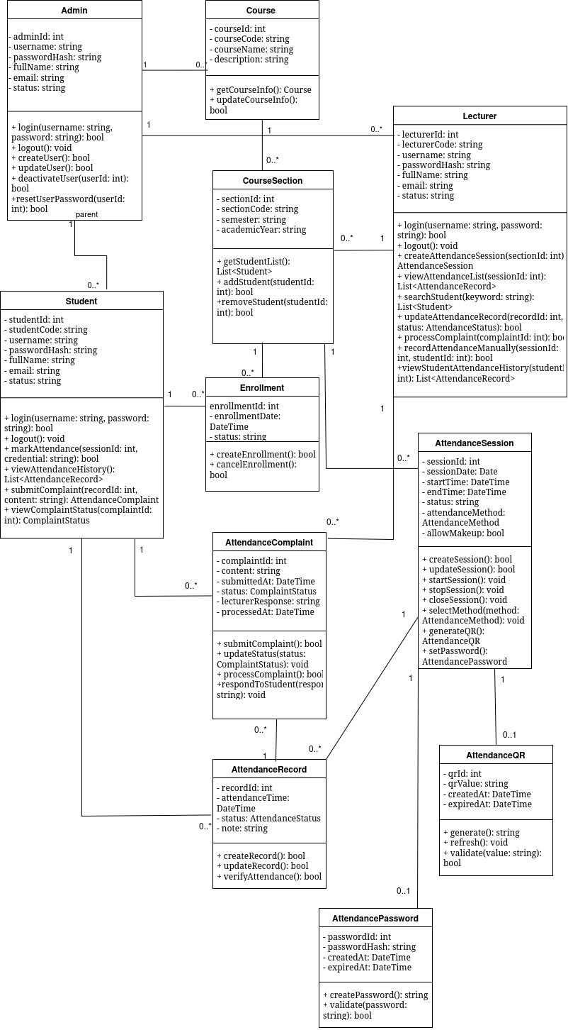
- Data model
VII. INTERFACE DESIGN DESCRIPTION



